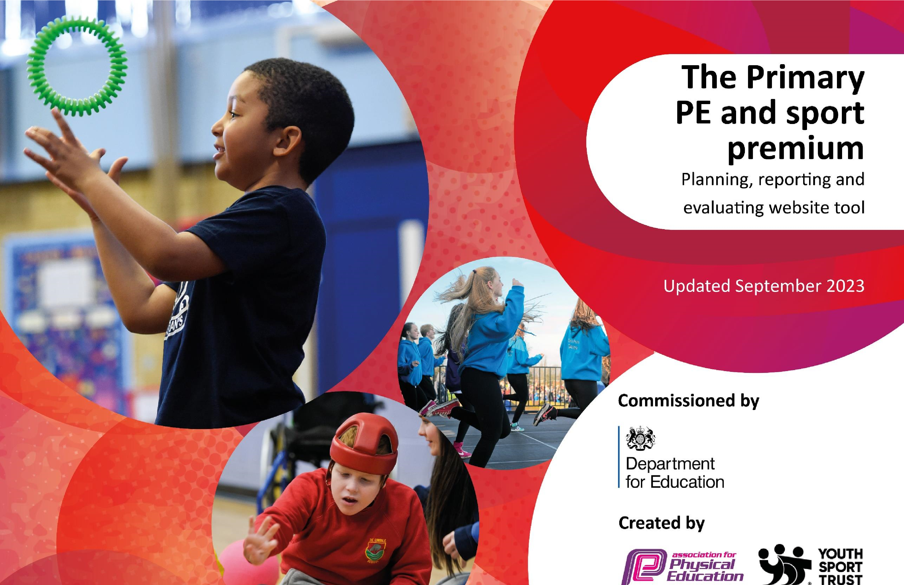







20
23
/
24

Additions by:

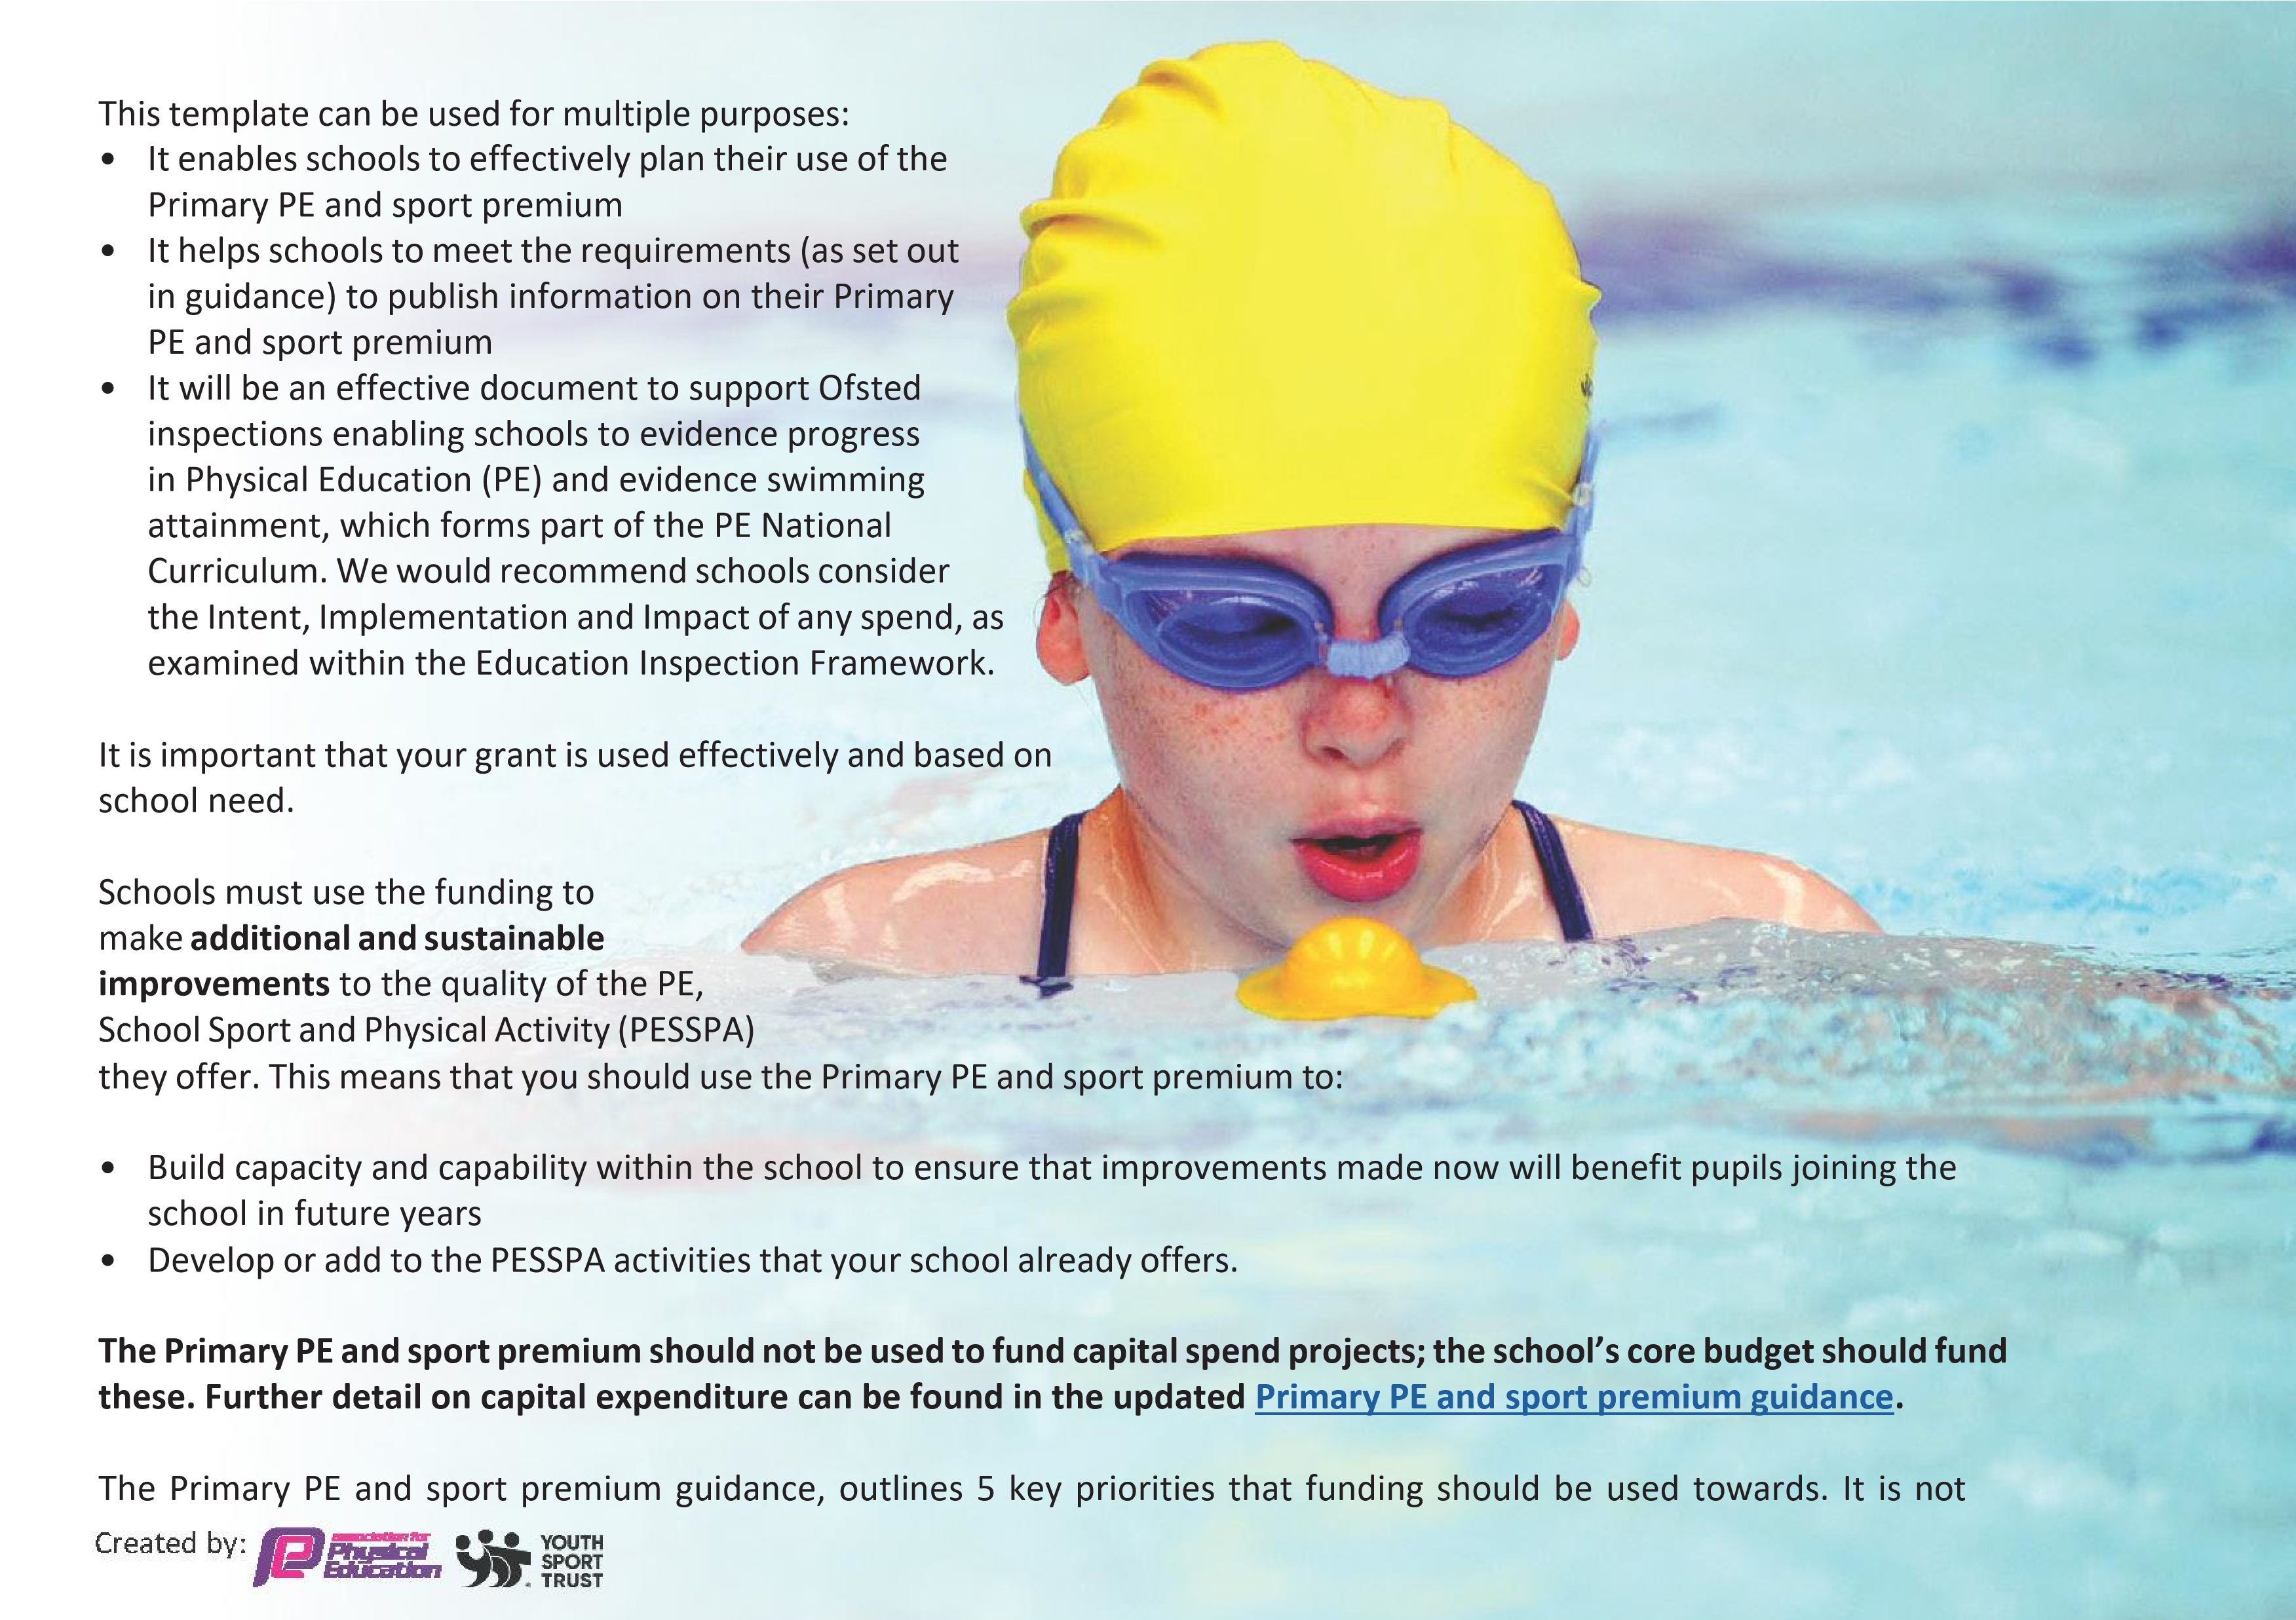
necessary that spending has to meet all the key priorities, you should select the priorities that you aim to use any funding towards.

Although completing this template is not a requirement for schools, schools are required to publish details of how they spend this funding. Schools must also outline what the impact this funding has had on pupils’ PE and sport participation and attainment and how any spending will be sustainable in the future. All funding must be spent by 31st July 2024.

The Department for Education has worked closely with the Association for Physical Education (afPE) and the Youth Sport Trust (YST) to develop this template and encourages schools to use it. This template is an effective way of meeting the reporting requirements of the Primary PE and sport premium.

Review of last year’s spend and key achievements (2022/2023)

We recommend you start by reflecting on the impact of current provision and reviewing your previous spend



In line with the requirements contained within last years’ national PE & Sport Premium template, at the end of the last academic year we reviewed our spend and key achievements. We then completed the ‘Next Steps’ and sustainability column on last years’ version of the national PE & Sport Premium template. One key purpose of this exercise was to inform and support our planning and spend for this academic year. Based on this review please now see our current plans and related spend below.

Academic Year: 2023/24 | Date Updated: 15/07/2024

Budget Summary for 2023/24

Underspend (
Figure carried forward)

-

£
0

202
3
/2
4

Premium

-

£
17
,
2
10

Total Funding Available

-

£
17
,
2
10

Key Indicators
Schools should prioritise PE and sport premium spending to improve in the following 5 key areas*

1. increasing all staff’s confidence, knowledge and skills in teaching PE and sport
2. increasing engagement of all pupils in regular physical activity and sport
3. raising the profile of PE and sport across the school, to support whole school improvement
4. offer a broader and more equal experience of a range of sports and physical activities to all pupils
5. increase participation in competitive sport

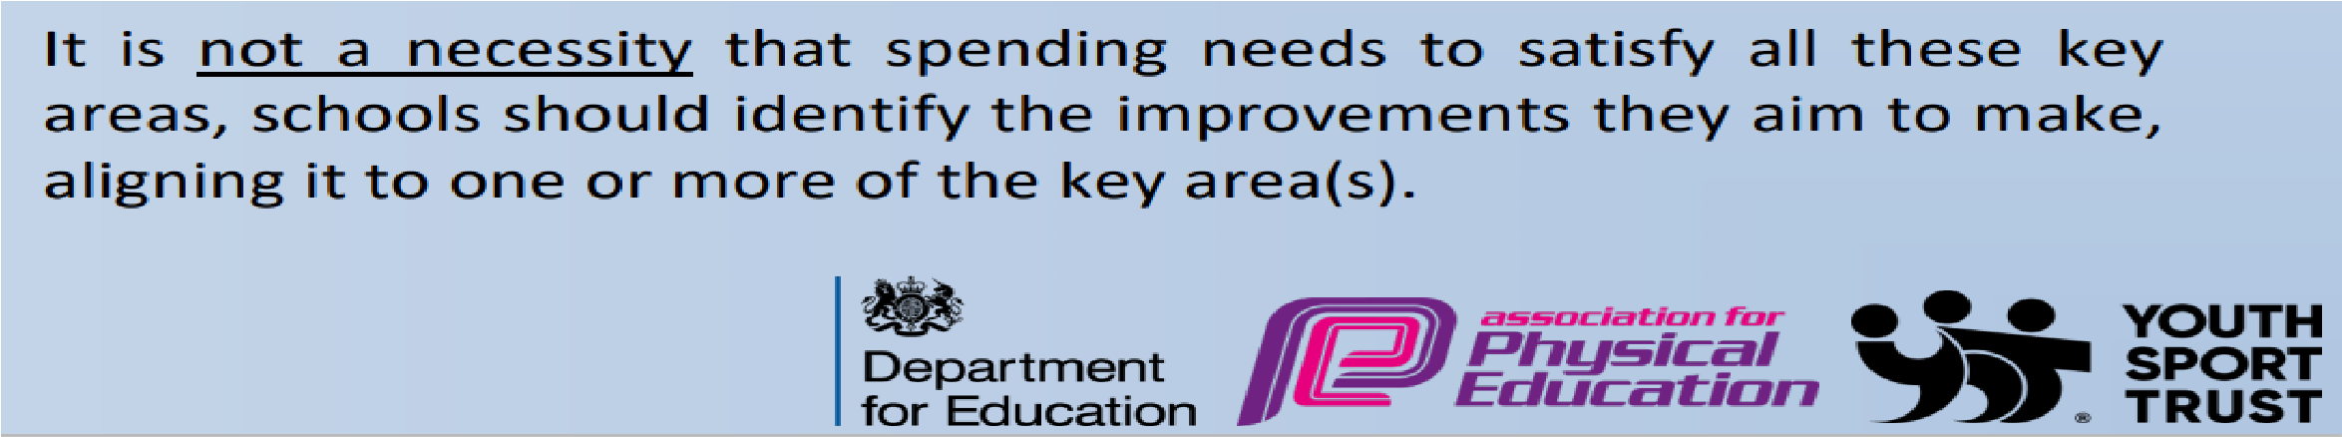

*

Key Priorities and Planning
This planning template will allow schools to accurately plan their spending.

Action – what are you planning to do | Who does  this action impact? | What Key Indicator(s) does this meet? | Impact, Evidence and how sustainability will be achieved? | Cost linked to the action
(1) Staff CPD Programme  A. Re-visit staff CPD needs and support for new PE Lead  - Informal discussions with staff  - Key focus on any new staff and ECTs  - PE Learning Walks to help identify needs  - Ensure future actions support Physical Activity requirements / recommendations contained in the Department for Education Guidance  - PE Lead with SLT to arrange support and purchase resources to meet needs  - Ensure that CPD that has taken place last year is cascaded to any new staff, through new to school induction.  - PE Lead with SLT to monitor impact of the CPD – PE Learning Walks / Pupil and Staff Voice  - Subject lead development programme with SLT.  - Whole staff CPD for Dance and Gymnastics with Allison Consultancy.  - Team-teaching opportunities with PE Specialist Coach to develop staff’s confidence and skills. | PE Lead  Class Teachers  Pupils | Key Indicators 1 and 3. | Evidence  - Discussions with staff  - Learning walk information  - Updates from PE Lead  - Pupil Voice  - Staff skill audit  Impact / Outcomes for staff:  - Identification of strengths and areas of staff need with regards to training  - More effective subject leadership  - Subsequent CPD bespoke to meet identified needs  - Engagement with GAT Networks.  - Staff have improved confidence in teaching PE to their own class and needs.  Impact / Outcomes for children:  - Children engaged in more effective, enhanced provision from upskilled staff  - Children accessed a broader range of provision, through CPD.  - Enhanced provision is given to pupils by upskilled staff.
 |  |  |  | £3595
Created by:
 | PE Lead  Class Teachers  Pupils | Key Indicators 1,2, and 4. | Evidence  - Membership purchased  - 2 x in-school training days from Allison Consultancy taken place  - Subscription for schemes of work purchased  - Equipment purchased  - Training from Sports Coaching taken place  - Engagement with SSP  - Discussions with staff and children  - Sport Leaders in place.  Impact / Outcomes for staff:  - Enhanced subject leadership  - Increased awareness of the national PE & Sport Premium Web Reporting and Action Plan Template  - Clearer understanding of the updated National Outcome Indicators  - A more focused action plan to enhance standards of provision incorporating greater sources of evidence and increased impact / outcome statements for both staff and children  - New, enhanced Long and Medium Term Plans in place to support enhanced teaching and learning for staff and children in PE using new lesson plans – increased confidence, knowledge and understanding to plan and deliver more effective PE lessons that engage children  - Staff upskilled to deliver enhanced provision in PE lessons  - Sustainability: new resource in place and can be used year on year  - New schemes will support staff to plan and deliver more effective PE lessons
B. TRUST – GAT PE Membership Support Package
Purchase membership of TRUST PE CPD and Sports Programme. Support to include:
- Allison Consultancy to plan and deliver Professional Learning Sessions and provide resources.
- Allison Consultancy to provide children.

3 x Central TRUST PE Co-ordinator Network Development Days

Support to include:

- Updates and guidance on latest national and Trust requirements
- PE & Sport Premium - DfE Conditions of Grant and national guidance / Ofsted information
- PE & Sport Premium – new national template and planning
- Website compliancy review
- Data collection Resources for PE & Sport Premium
- Equipment & Resources review of safe practice compliancy
- Sharing of best practice
- PE Lead to continue to attend PE training days and liaise with Senior Leaders and staff
- Access to Sport Plan (12000 lesson plans)

 |  |  |  | £1000
 |  |  |  | £1700
Created by:
 |  | PE Lead  Teachers  Pupils | Key Indicators 1 and 3 | Impact / Outcomes for children:  - Key Strategic actions Identified ensuring the greatest, most sustainable outcomes for our staff and children  - Enhanced opportunities for healthy exercise  - Children engaged in enhanced, more effective PE lessons  - Children engaged in more effective, enhanced PE provision from upskilled staff  - All children involved in more regular, healthy, sustained, vigorous physical activity in PE  - Enhanced quality of learning  - Improved challenge and engagement across  all pupils  - Leads to greater pupil progress and attainment in PE against national, age-related expectations
Purchase Equipment / resources to support CPD
- Purchase subscription for Primary PE Planning
- Audit PE equipment.
- Create whole school map to show progression opportunities for children.
- Order required equipment to facilitate the curriculum.
- Monitor the use of equipment.

 |  |  |  |  | £1824.61
Created by:
(2) Extend Physical Activity Opportunities for Pupils  A. Extend extra-curricular offer.  - Conduct a pupil voice survey to gather data.  - Extra-curricular clubs to be planned to give children further opportunities and experiences.  - Monitor participation and impact of sport clubs.  - Target engagement through monitoring of participation.  - Premier Education to offer additional club provision.  - Transport to competitions.  B. Develop activities for pupil engagement and physical activity at breaks and lunchtimes.  - Train sport leaders to lead lunchtimes and playtime games.  - Invest in sports equipment to support provision.  - Installation of Traverse Wall in the playground.  - Purchasing of balance bikes and tricycles.  - Staff training for staff to support pupil engagement. | PE Lead  Class teachers  Pupils  Class teachers  Pupils | Key Indicators 1,3,4 and 5  Key Indicators 1,2 and 3 | Evidence  - Sports Coaches engaged  - Participation / Club Registers  - Extended Extra-Curricular Sport and Physical Activity Programme  - Pupil / Staff Voice data  - Equipment purchased  - Sport Leader training  - Purchasing of training and resources.  Impact / Outcomes for children  - More pupils meeting their daily physical activity goal  - 30 Minute-a-Day target achieved by more pupils  / classes across the school  - More pupils encouraged to take part in PE and Sport Activities.  - Greater understanding and enhanced knowledge about the benefits of healthy physical activity  - Increased awareness of the wide range of different types of healthy activity available  - Increased opportunities for healthy activity available  - Increased engagement in exercise  - Improvement in health and well-being  - Increased participation by children who normally do not engage with sporting / physical activity opportunities  - Enhanced sense of well-being  - Greater understanding of how involvement in
 |  |  |  | £5571.94
 |  |  |  | £1670
Created by:
C. Extend Competitive Opportunities for pupils and support the development of the whole child through the achievement of whole school outcomes because of a focus on PE, School Sport and Physical Activity  A. Inclusive competitive PE Curriculum Sports / Physical Activity Competition Programme  - Continue to extend competitive opportunities from within the PE Curriculum itself so competitive opportunities become more inclusive are increased and available to all  - PE Lead to ensure staff are supported to provide competitive opportunities in PE lessons so competition is available to all children  - Give all children more opportunities over the school year to experience competitive opportunities  - Ensure all staff carry out their own mini competitive activity at the end of at least 2 PE Units of Work over the year  - Competitions must involve ALL children  B. Participate in GAT Competitions  - Engage in TRUST and local Cluster competitions  - Look at triangulation events / mini-festivals  - Look at competition opportunities for children that do not usually get to represent the academy  - Coach to work with children before events come up | PE Lead  Class teachers  Pupils  PE Lead  Class teachers  PE Lead | Key Indicators 3,4 and 5  Key Indicators 3,4 and 5 | healthy physical activity can help them with self-confidence, better behaviour, and concentration in lessons  Evidence  - Participation in GAT Trust  - PE Units of Work developed to include competitive opportunities  - New sports and physical activity competitive opportunities in place  - Participation registers  - Resources to plan and deliver programme  - Celebration assemblies  Impact / Outcomes for staff:  - Sustainability – Teaching staff able to deliver competitive sport / physical activity opportunities for their children in lessons  Impact / Outcomes for pupils:  - Experience of competition against self and others  - Experience and understanding of rules and scoring systems  - Experience and understanding of how to work as a team and how to handle winning and losing and the importance of good sportsmanship  - Confidence  - Enjoyment of sport across the school  - Opportunities to participate in a wider variety of activities  - Awareness of the importance of physical activity and health.  - Socialisation with other children from other schools / backgrounds.  - Experience of sense of well-being and the feeling of achieving their best.
 |  |  |  | £250
Created by:

Key achievements 2023-2024

This template will be completed at the end of the academic year and will showcase the key achievements schools have made with their Primary PE and sport premium spending.

Activity/Action |  |  |  |  |  |  |  |  |  |  |  |  |  | Impact | Comments
1. |  | Staff CPD Programme |  |  |  |  |  |  |  |  |  |  |  | - Sequential curriculum with small steps mapped out.  - Staff have expressed increase in confidence and knowledge when teaching dance and gymnastics.  - Pupil participation and activity has increased during lessons.  - Staff have increased confidence when teaching dance and gymnastics.  - Accelerated progress for the implementation of the PE planning package.  - Broad and balanced range of PE sports and activities,  - Enhanced playtime provision to ensure children achieve their 30 minutes of activity a day.  - Improved resources to support development of muscle groups given missed learning due to Covid.  - Increased leadership opportunities for children  (sport leaders)  - All children given the opportunity to attend extra-curricular dance club. Those in attendance competed in East Midlands dance competition.  - Children from Years 5 and 6 represented the school in GAT level Athletics competition.  - Children have experienced different scoring systems.  - Promotion of school values in-line with being resilient and having a healthy body and mind.  - Achievements have been shared in assembly.  - Children have the opportunity to socialise with children from a range of backgrounds.  - Children develop the understanding of sportsmanship. | Children have the opportunity to develop previous skills and make progress over the course of their time at The Bramble Academy. Children have access to a broader range of sports to support them develop their skills and knowledge as they prepare for their next steps in learning.  An increase in resources has supported more children to be active during lesson. Staff have reported that the access to planning support has increased confidence when teaching PE.  Children have been targeted to be Sport Leaders, this has increased the physical activity at breaktimes and lunchtimes. All extra-curricular clubs have been over-subscribed, pupil voice has been used to inform the menu of opportunities available.  Pupil voice shows that children take pride when representing the school All children from the Dance club attended the competition, there has been an increase in parental engagement with competitions, with families attending the Dance competition to support the children.  Pupil voice has shown that children are exciting by competitions, and younger children have aspirations to attend the GAT Athletics competition.
A. Re-visit staff CPD needs and support for new PE Lead |  |  |  |  |  |  |  |  |  |  |  | .
B. TRUST – GAT PE Membership Support Package
C. Purchase Equipment / resources to support CPD
 | 2. Extend Physical Activity Opportunities for Pupils
A. Extend extra-curricular offer
B. Develop activities for pupil engagement and physical
activity at breaks and lunchtimes.
 | 3. Extend Competitive Opportunities for pupils and
 |  | support the development of the whole child
 |  | through the achievement of whole schoo |  |  |  |  |  |  | l
 |  | outcomes because of a focus on PE, School Sport
 |  | and Physical Activity
A. Inclusive competitive PE Curriculum Sports / Physical
Activity Competition Programme
B. Participate in GAT Competitions

Budget Summary as of 26/6/24

Total Funds (Including any underspend) - £17,210.00

Total Spend so Far - Identified in Plan (‘Blue’ figures) - £15,611.55

Left to Spend - £1598.45

Swimming Data

Meeting National Curriculum requirements for swimming and water safety.
Priority should always be given to ensuring that pupils can perform safe self-rescue even if they do not fully meet the first two requirements of the National Curriculum programme of study

Question | Stats: |  |  |  |  | Further context  Relative to local challenges
What percentage of your current Year 6 cohort can swim competently, confidently and proficiently over a distance of at least 25 metres? | 32% |  |  |  |  | This was the first time this cohort attended swimming.
What percentage of your current Year 6 cohort can use a range of strokes effectively [for example, front crawl, backstroke, and breaststroke]? | 8% |  |  |  |  | This was the first time this cohort attended swimming.
What percentage of your current Year 6 cohort are able to perform safe self-rescue in different water-based situations? | 0% |  |  |  |  | Time taken to progress through swimming curriculum restricted the access to this area of learning.
If your schools swimming data is below national expectation, you can choose to use the Primary PE and sport premium to provide additional top-up sessions for those pupils that did not meet National Curriculum requirements after the completion of core lessons. Have you done this? | Yes/ |  |  | No |  | Needs of the school meant this was not possible.
Have you provided CPD to improve the knowledge and confidence of staff to be able to teach swimming and water safety? |  | Yes | /No

Signed off by:

Head Teacher: | Panayiota Theodosiou
Subject Leader or the individual responsible for the Primary PE and sport premium: | Panayiota Theodosiou  Principal
Governor:
Date: | 15th July 2024

