Year  Group | Concepts /  NC Aims | PE Pillars of Progression  (Ofsted, 2022) | Autumn | Spring | Summer | National Age-Related Expectations  EYFS ELGs / NC Attainment Targets
R | Personal, Social and Emotional Development  Physical Development  Expressive Arts and Design | Including Context-Specific Motor Competence (Fundamental Movement Skills)  Healthy Participation  Rules, Strategies and Tactics Simple Tactics  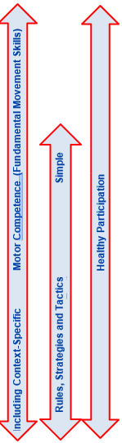 | 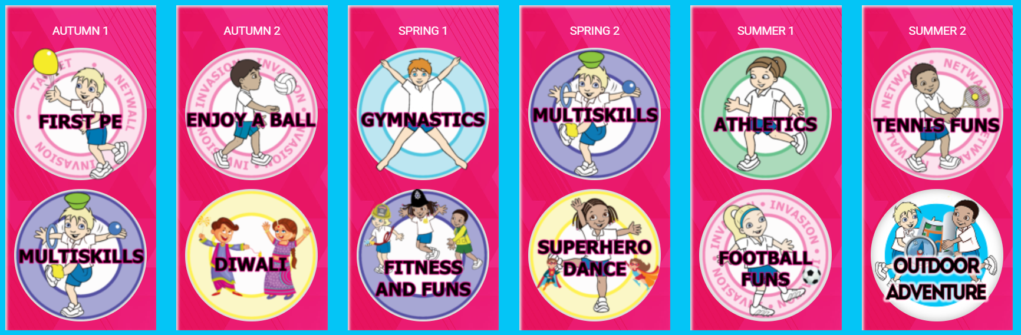 |  |  | PSED ELG: Be confident to try new activities and show independence,  resilience and perseverance in the face of a challenge.  Explain the reasons for rules, know right from wrong and try to behave accordingly  Manage their own basic hygiene and personal needs, including dressing  Work and play cooperatively and take turns with others.  PD ELG: Negotiate space and obstacles safely, with consideration for themselves and others.  Demonstrate strength, balance and coordination when playing.  Move energetically, such as running, jumping, dancing, hopping, skipping and climbing.  EAD ELG: Perform songs, rhymes, poems and stories with others, and (when appropriate) try to move in time with music.
1 | Develop competence to excel in a broad range of physical activities.  Are physically active for sustained periods of time.  Engage in competitive sports and activities.  Lead healthy, active lives. |  | 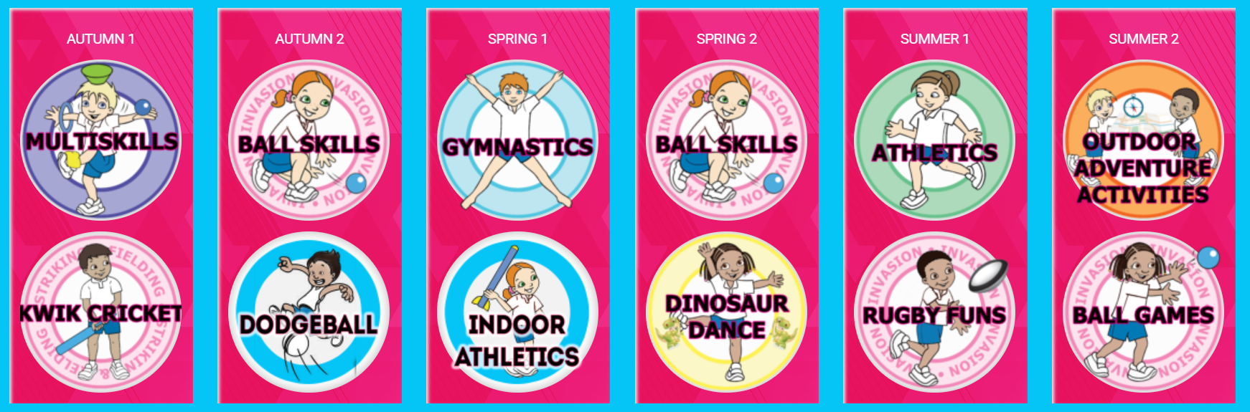 |  |  | Pupils should develop fundamental movement skills, become increasingly competent and confident and access a broad range of opportunities to extend their agility, balance and coordination, individually and with others.  They should be able to engage in competitive (both against self and against others) and co-operative physical activities, in a range of increasingly challenging situations.
2 |  |  | 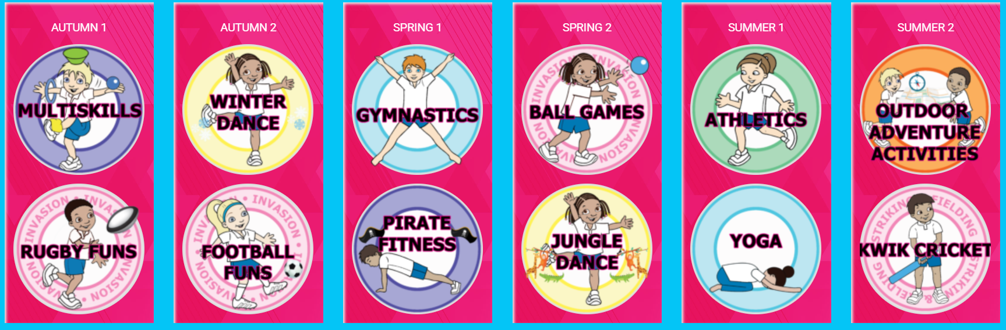
3 |  |  | 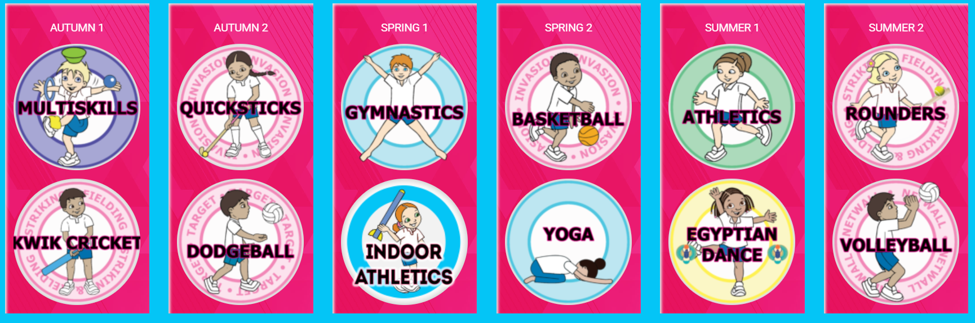 |  |  | Pupils should continue to apply and develop a broader range of skills, learning how to use them in different ways and to link them to make actions and sequences of movement.  They should enjoy communicating, collaborating and competing with each other.  They should develop an understanding of how to improve in different physical activities and sports and learn how to evaluate and recognise their own success.  Swimming and water safety  Swim competently, confidently and proficiently over a distance of at least 25 metres  Use a range of strokes effectively [for example, front crawl, backstroke and breaststroke]  Perform safe self-rescue in different water-based situations.
4 |  |  | 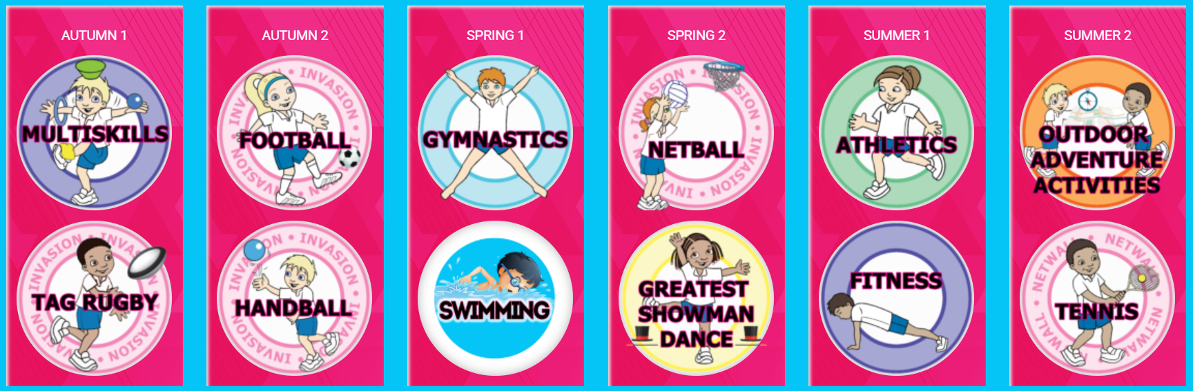
5 |  |  | 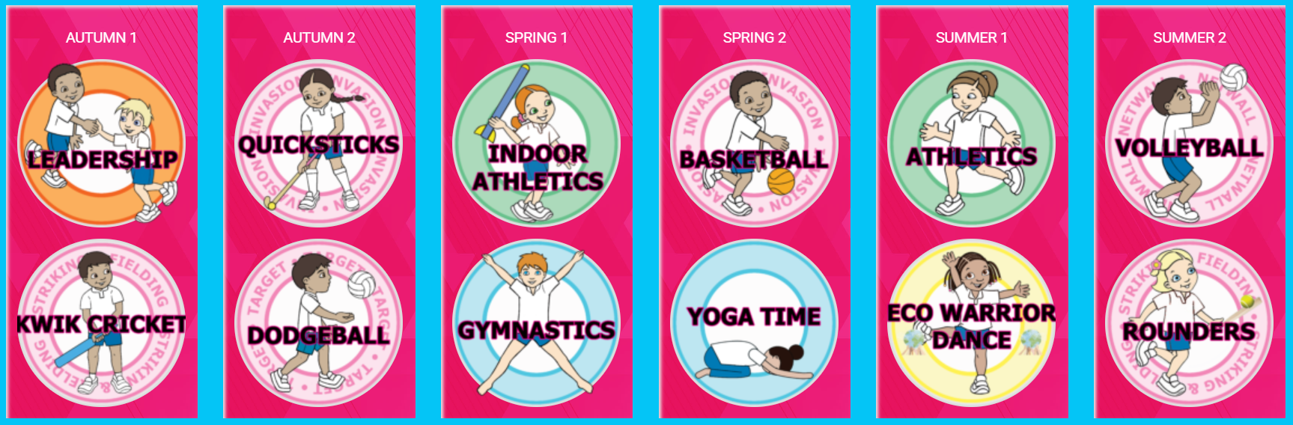
6 |  |  | 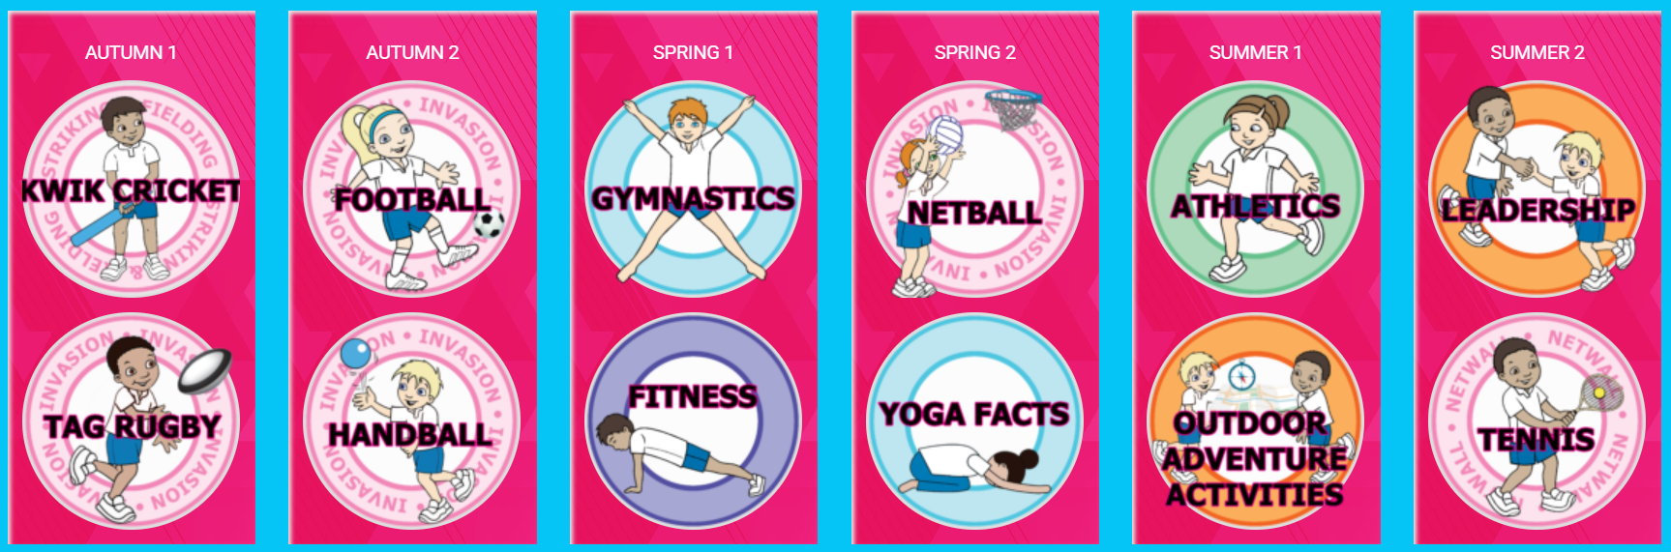
NB: Primary PE Planning is used to support planning and teaching. Progression across EYFS – Y6 is mapped out on the academy’s individual curriculum map. All curriculum progression information can be found here:
https://primarypeplanning.com/curriculum-map/?share=gXecBdi_tZip62KMhCaYa9yM05qgSe1ZXjCwgCs5Y7s
KS3 AIMS | Pupils should build on and embed the physical development and skills learned in key stages 1 and 2, become more competent, confident and expert in their techniques, and apply them across different sports and physical activities.  They should understand what makes a performance effective and how to apply these principles to their own and others’ work.  They should develop the confidence and interest to get involved in exercise, sports and activities out of school and in later life, and understand and apply the long-term health benefits of physical activity.

